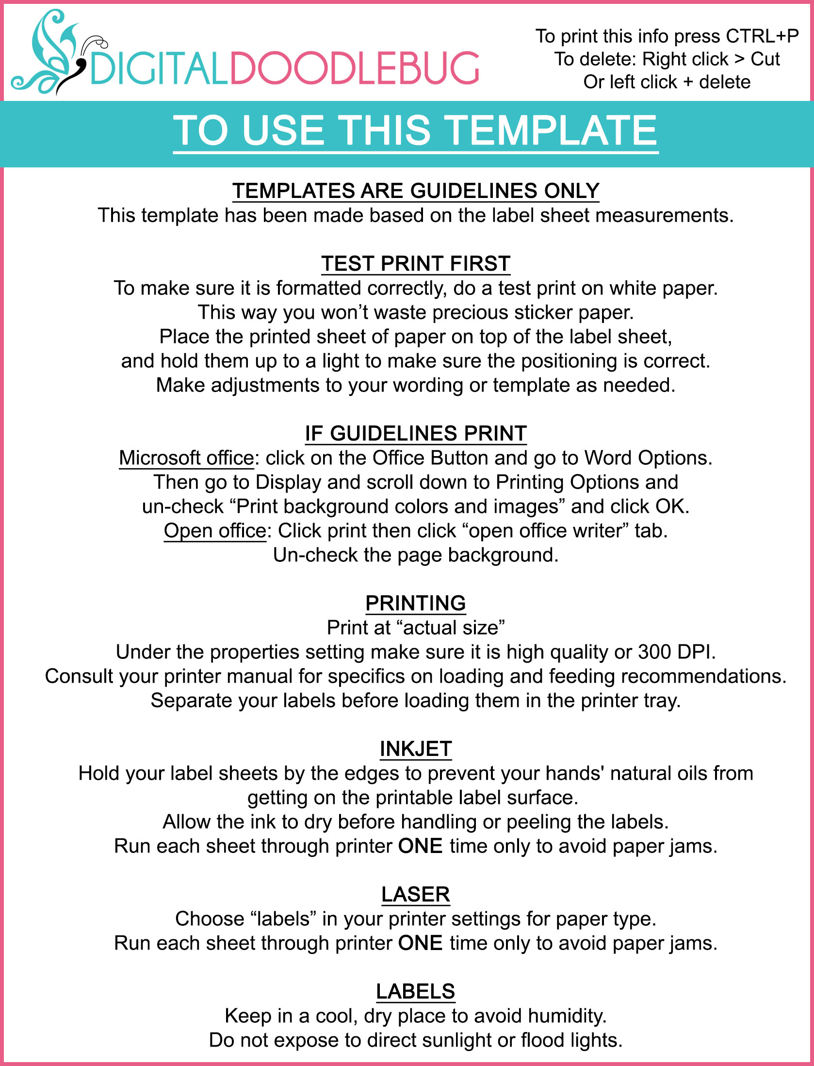
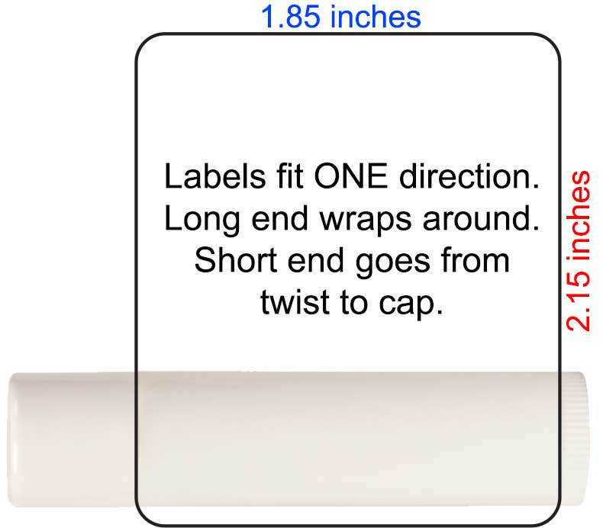
Your words and graphics here
Your words and graphics here
Your words and graphics here
Your words and graphics here
Your words and graphics here
Your words and graphics here
Your words and graphics here
Your words and graphics here
Your words and graphics here
Your words and graphics here
Your words and graphics here
Your words and graphics here
Your words and graphics here
Your words and graphics here
Your words and graphics here

