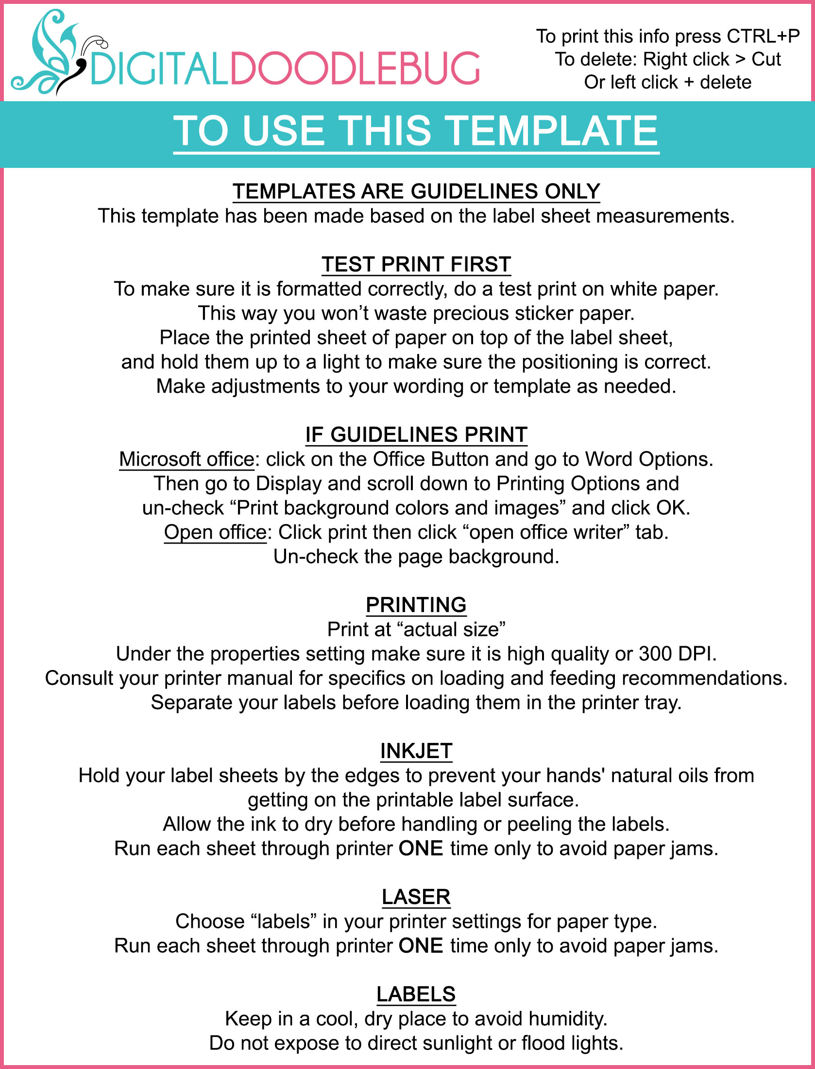
Jeans
Tshirts
Dresses
Sleeveless
Jackets
Long Sleeve

