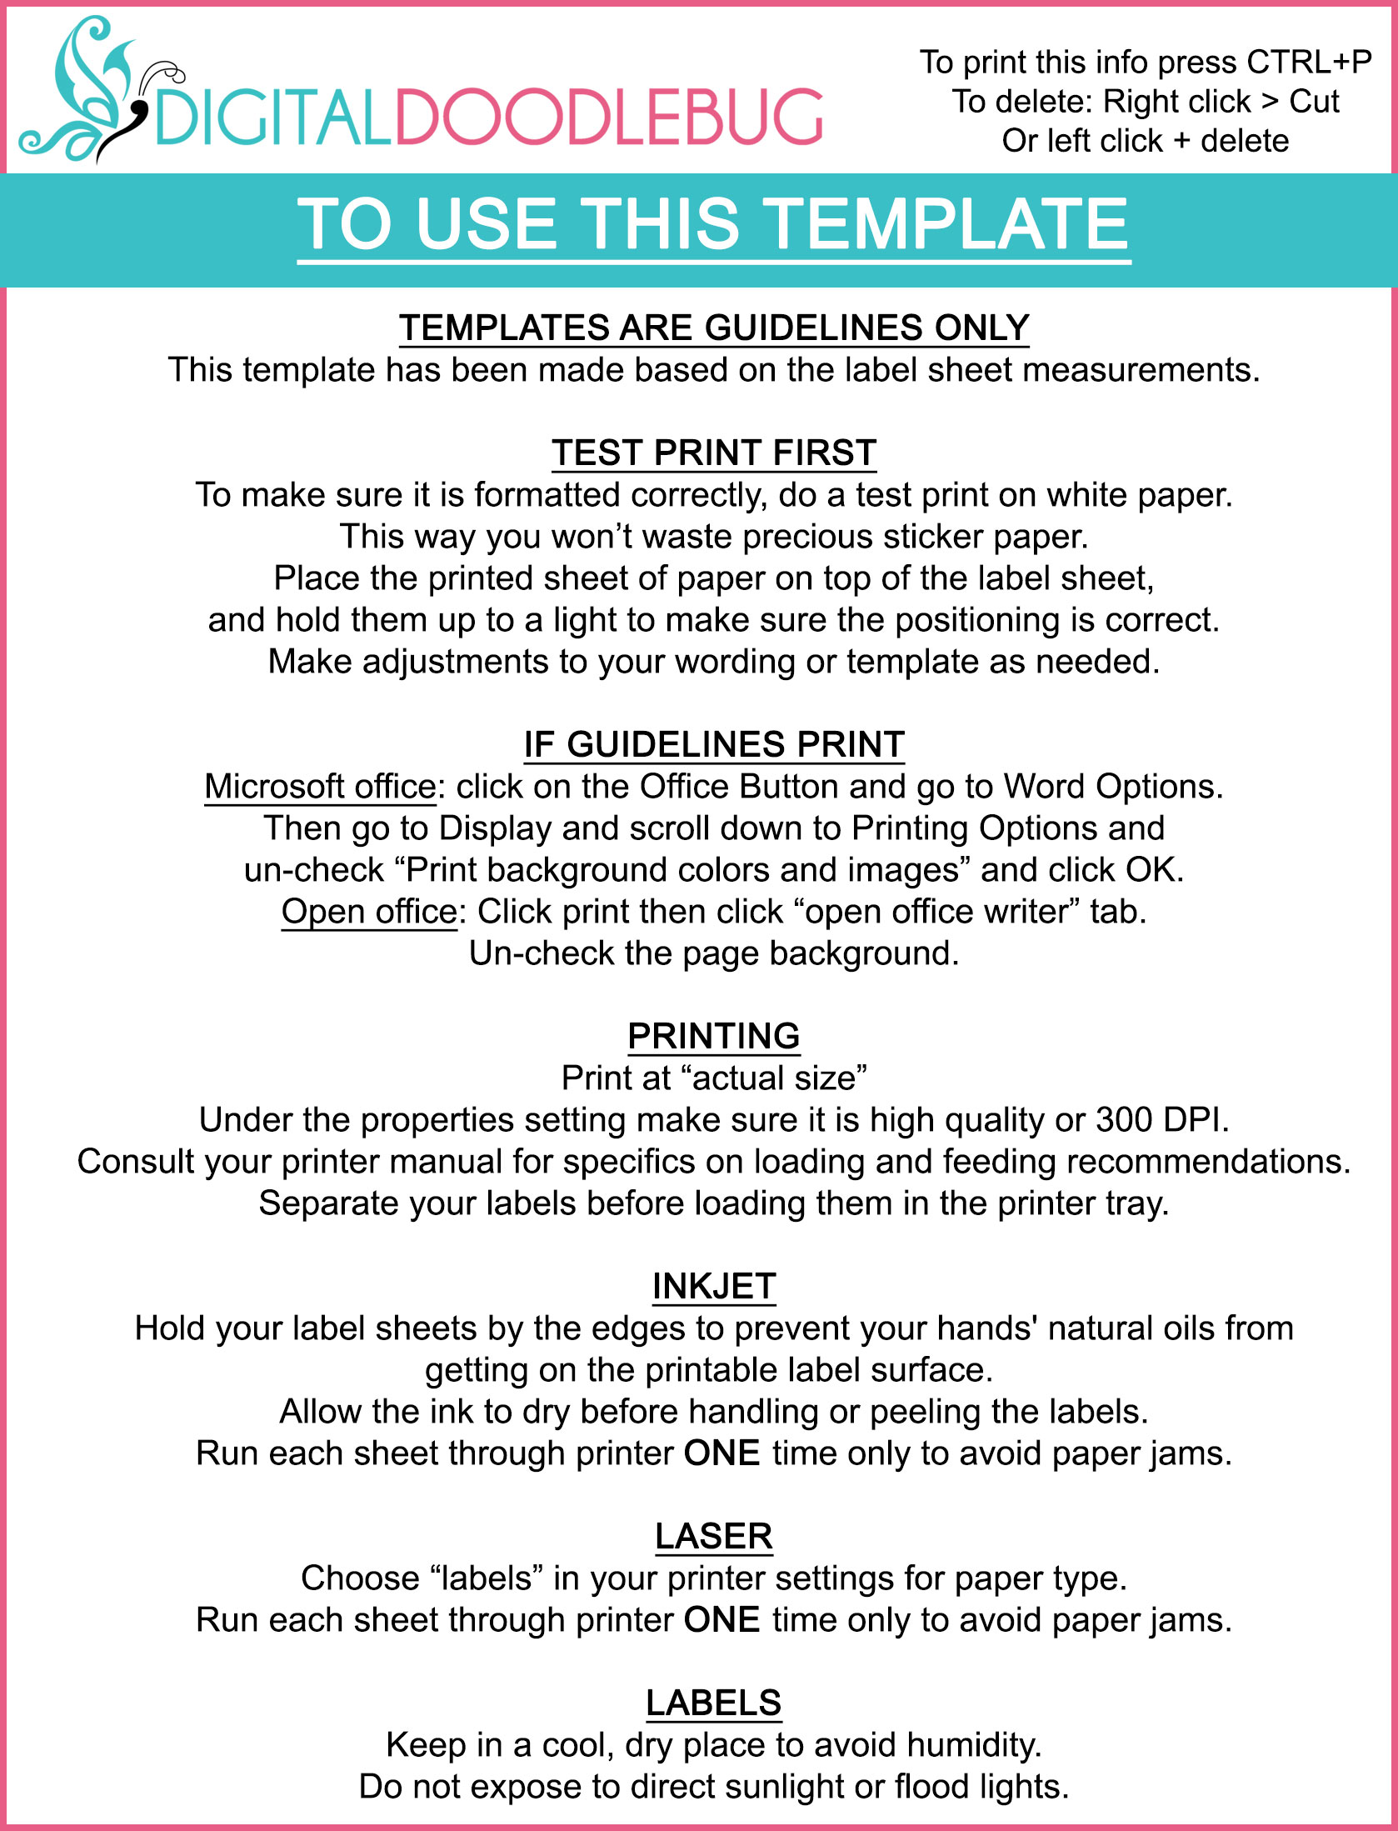
HANDMADE

Natural Lip Balm
Info
Info
Info
Info
Info
Info
Info
Info
Info
Info

